



Sunday 20th April 2025
‘To know God for ourselves. To grow in God together. To share God with others’

17th April Maundy Thursday

6.30pm Church House meal, to attend please email revpete07@gmail.com
7.30pm Maundy Thursday service, Newport 1 Corinthians 11.23-26 John 13.1-17, 31b-35
18th April Good Friday

10.30am Easter Messy Church

2-3pm An hour by the Cross, Widdington

20th April Easter Sunday

9.30am Holy Communion and Sunday Club, Newport Acts 10. 34-43
Luke 24. 1-12
11.15am Holy Communion, Widdington Acts 10. 34-43
Luke 24. 1-12
11.15am Morning Worship, Rickling Acts 10. 34-43
Luke 24. 1-12
27TH April Second Sunday of Easter

9.30am Morning Worship, Newport Acts 5.27-32
Psalm 118.14-29

11.15am Holy Communion, Rickling Acts 5. 27-32
Psalm 118.14-29
COLLECT MAUNDY THURSDAY
God our Father,
you have invited us to share in the supper
which your Son gave to his Church
to proclaim his death until he comes:
may he nourish us by his presence,
and unite us in his love;
who is alive and reigns with you,
in the unity of the Holy Spirit,
one God, now and for ever.

AMEN

COLLECT EASTER SUNDAY
Lord of all life and power,
who through the mighty resurrection of your Son
overcame the old order of sin and death
to make all things new in him:
grant that we, being dead to sin
and alive to you in Jesus Christ,
may reign with him in glory;
to whom with you and the Holy Spirit
be praise and honour, glory and might,
now and in all eternity.
AMEN

THIS WEEK
BH Monday 21st April 2pm Easter Trail, Newport
Tuesday 22nd April 10am Online Morning Prayer
Wednesday 23rd April 10am Coffee morning Newport
Wednesday 23rd April 10am Coffee morning Widdington
(then 3 week break)
Thursday 24th April 10am St Clare Hospice coffee morning
FURTHER AHEAD
Monday 28th April 10am Little Fishes Widdington
Tuesday 29th April 9am Online Morning Prayer
Wednesday 30th April 10am Coffee morning Newport
Thursday 1st May 10am Knit and Natter Newport
Saturday 3rd May 9am Morning Walk, Newport
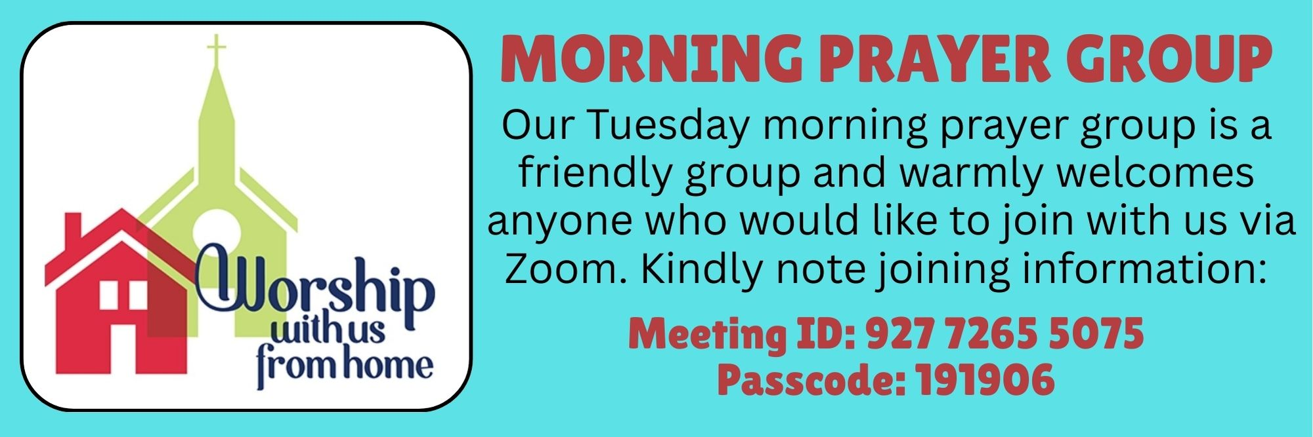

https://rbs.zoom.us/j/92772655075?pwd=Z0tsUzljcm5vS0Vnb0Z1Sml1ZnU2Zz09

Please Pray
For our services led by the Peter Allen, Gavin Sunshine and the Messy church team

For the friends and family of Ron Woodthorpe who passed away on April 6th.
For Berenice and her family following the loss of her husband John Smith.
For the healing of Michael Hughes, Gary H, Ben and Kay Ledden, Rob Griffiths, Margaret Moule, Martin Folland, Charlotte, Sue Hurley, Pauline Potterill, Sylvia Wright and Louise, Julie Hancock, Beryl Sears and for God’s healing for those known to us.
May they all who suffer from cancer know the healing presence of God’s love.
For the people of Ukraine and all those caught up in conflict. We pray for peace and the laying down of weapons. For those with the power over war and peace, we pray for wisdom, discernment, and compassion to guide their decisions.
For the people of Israel and Gaza, for those suffering, we ask that God provides peace in this crisis and protection and comfort for all those who have been impacted.
For the work of Streets2Homes, Jimmy’s Night Shelter & other charities supporting homeless people.
Thank you for your prayers.
Contact church.jo@yahoo.com for prayer inclusions.



Message from Richard
Carolyn and Richard would like to say a big thank you to all those who helped us celebrate Carolyn's 70th birthday at Kappa House and who have supported us in many ways over the last few years.


PLENTY OF ACTIVITIES FOR THE CHILDREN THIS WEEKEND!

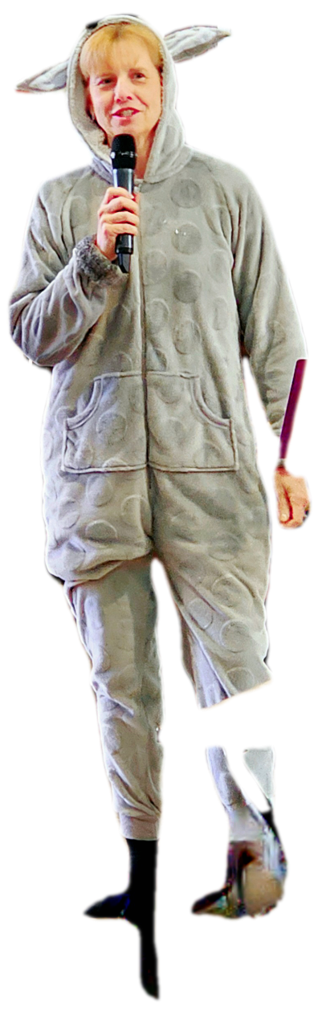

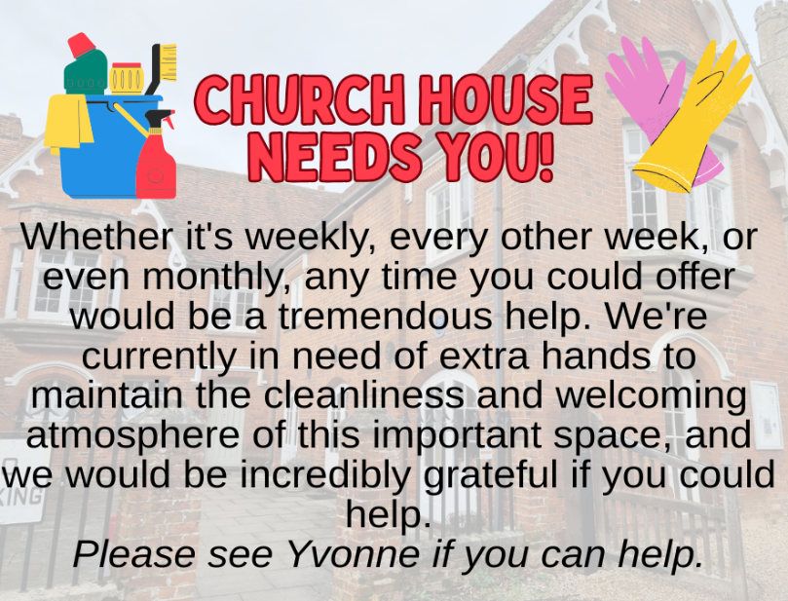
If you would like to bake a cake, help on the day or donate an Easter Egg for the Easter trail, there’s still time!



30 minutes help needed to serve refreshments if anyone has time? Please let Cheryl know.

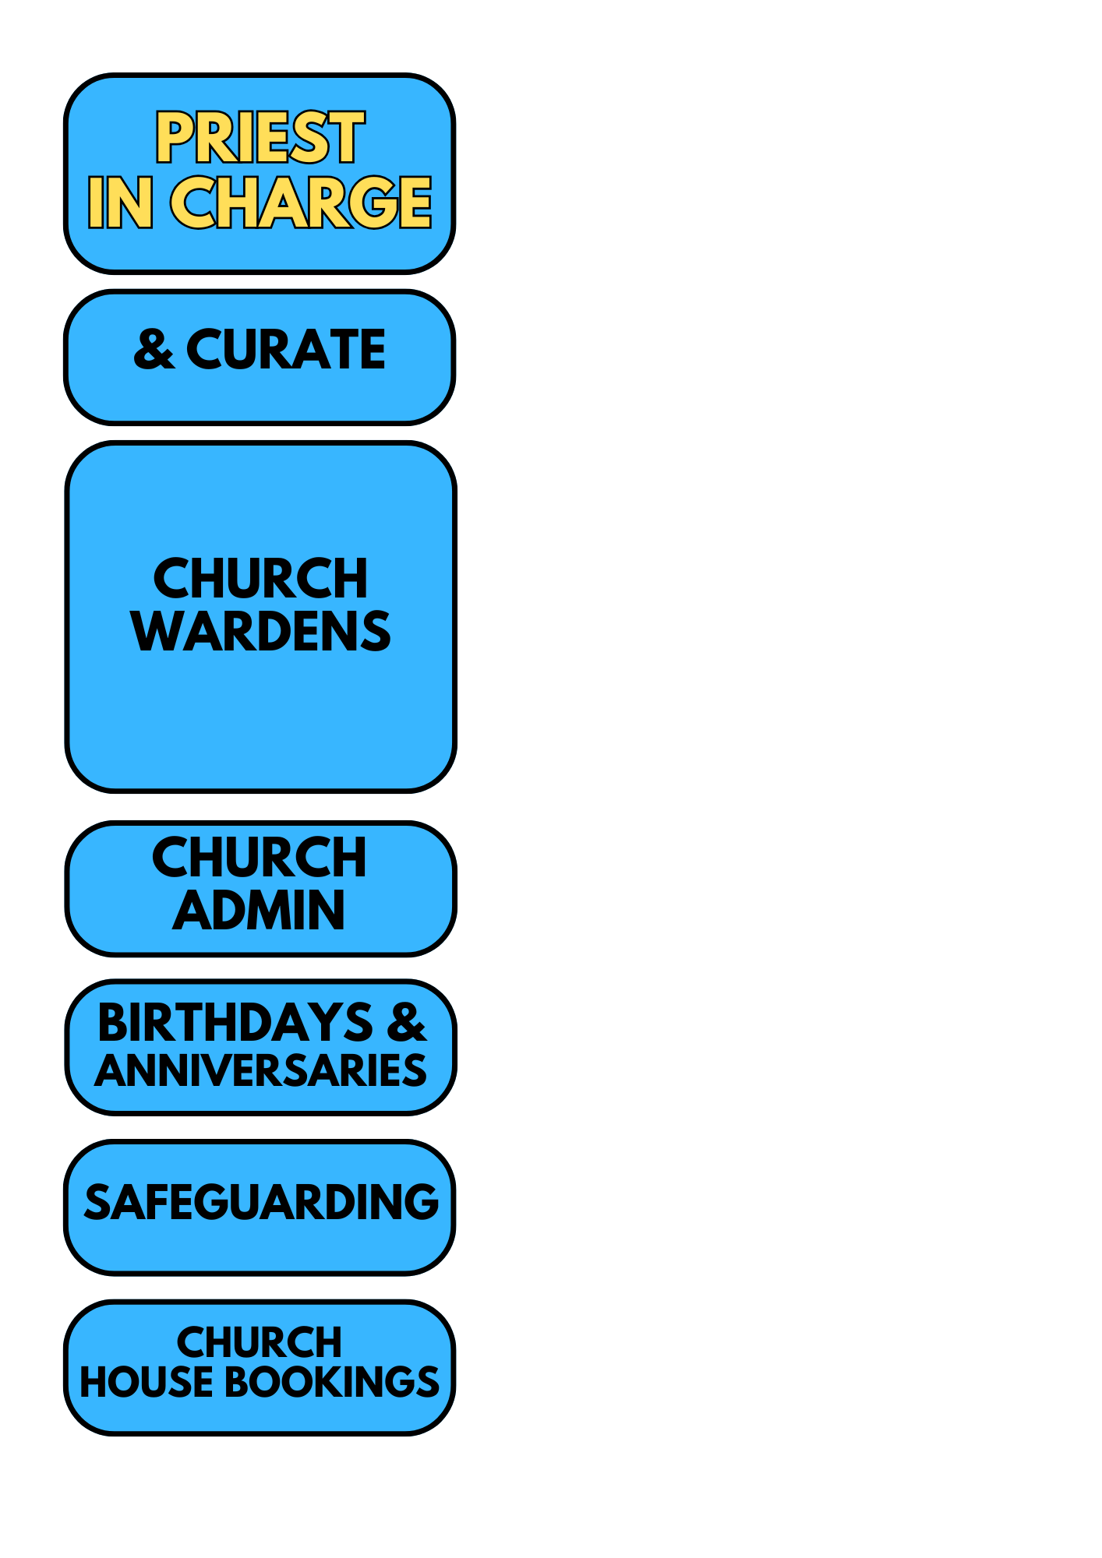
REVEREND PETER ALLEN
Priest at Newport, Widdington, Quendon and Rickling.
Lead Chaplain at Stansted Airport
07878 176551 revpete07@gmail.com

revpete07@gmail.com
REVEREND GAVIN SUNSHINE
07379 299845 revgav24@gmail.com

NEWPORT
Elaine Edwards
07540 062140 account2me2004@yahoo.co.uk
David Baker
07510 308068 david.baker123@talktalk.net
WIDDINGTON
Sonia Whalley
01799 540066 soniawhalley@aol.com
QUENDON & RICKLING
Christine Osbourn christineandos@gmail.com
Rickling contact vicar4nqrwchurches@gmail.com

Jo Cundall
07905 833372 church.jo@yahoo.com
Vicar4nqrwchurches@gmail.com
Church office open every
Friday 9am -10.30am from Friday 10th January

Sarah Godfrey
01799 541157 sarah_jane_godfrey@yahoo.co.uk

Contact: Vicar4nqrwchurches@gmail.com

We are committed to Safeguarding Children, Young People, Victims of Domestic Abuse and Vulnerable Adults.





CHURCH WEBSITES & SOCIALS
www.stmarynewport.org.uk
www.quendonandrickling.co.uk/churches/

Yvonne Hannant
01799 541063 churchhousenewport@hotmail.com






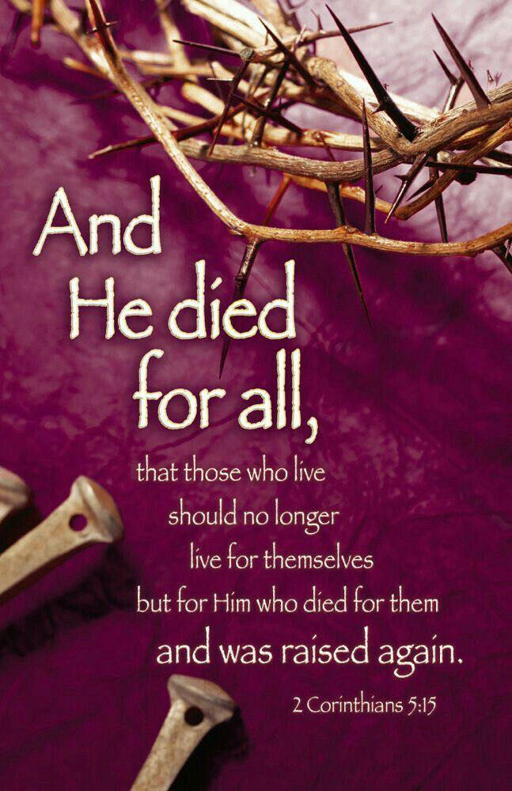
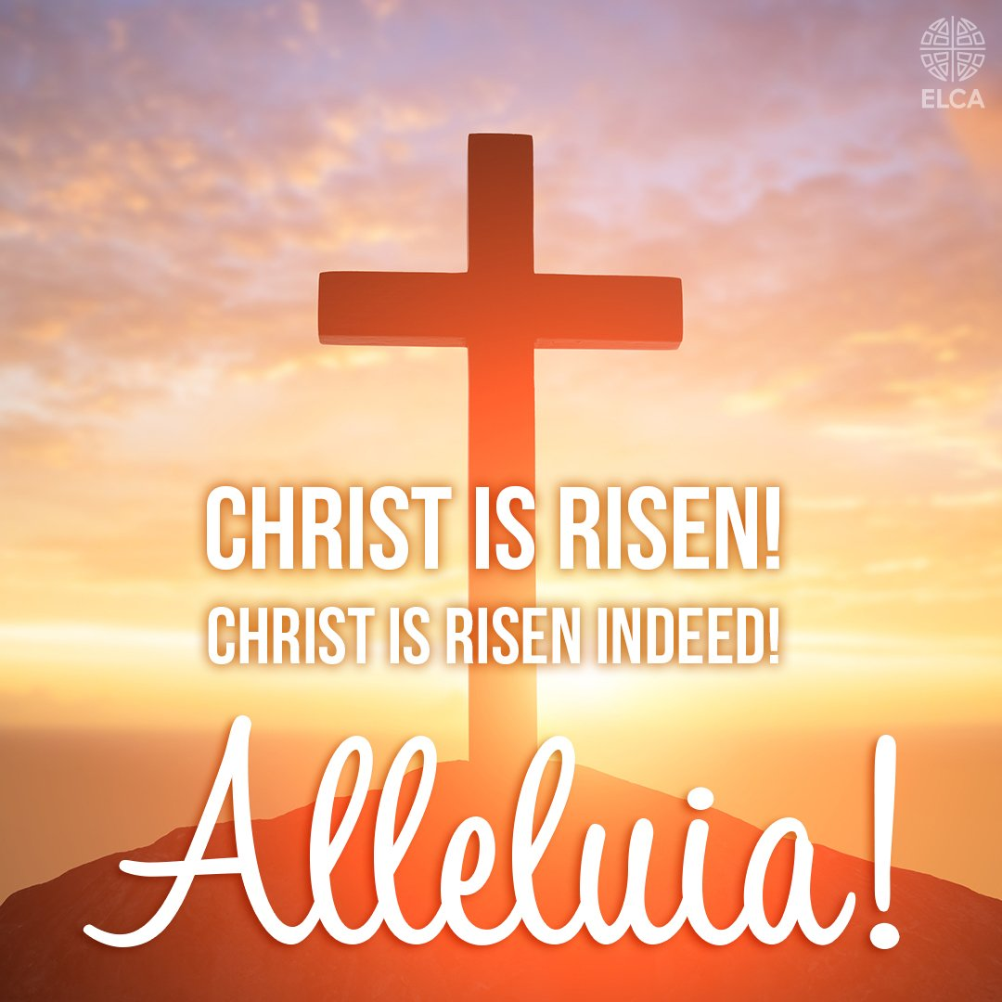
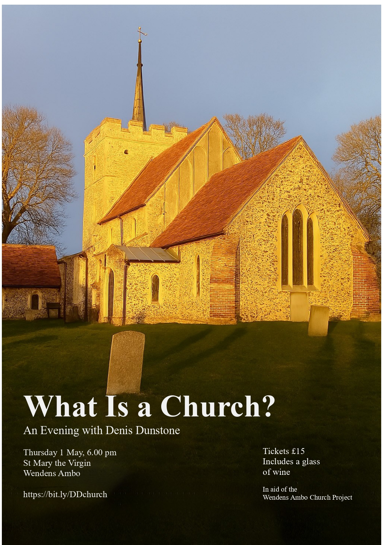

An invitation from St. Mary’s, Wendons Ambo.

