**Sunday 6th April 2025**

**‘To know God for ourselves. To grow in God together. To share God with othe**r**s**’

**6th April Fifth Sunday of Lent**

9.30am Contemporary Communion, Newport [John 17. 1-5](https://bible.oremus.org/?ql=609815063)

[John 17. 20-24](https://bible.oremus.org/?ql=609815109)

11.15am Holy Communion, Widdington [John 17. 1-5](https://bible.oremus.org/?ql=609815063)

[John 17. 20-24](https://bible.oremus.org/?ql=609815109)

**13th April Palm Sunday Holy Week**  (no live streaming)

9.30am All Age, Newport

11.15am Holy Communion, Quendon [Psalm 118.1-2,19-29](https://bible.oremus.org/?ql=610577881)

[Luke 19.28-40](https://bible.oremus.org/?ql=610581488)

**17th April Maundy Thursday**

6.30pm Church House meal, **to attend please email** <revpete07@gmail.com>

7.30pm Maundy Thursday service, Newport [1 Corinthians 11.23-26](https://bible.oremus.org/?ql=610578134)

[John 13.1-17, 31b-35](https://bible.oremus.org/?ql=610578189)

**COLLECT**

Most merciful God,

who by the death and resurrection of your Son Jesus Christ

delivered and saved the world:

grant that by faith in him who suffered on the cross

we may triumph in the power of his victory;

through Jesus Christ your Son our Lord,

who is alive and reigns with you,

in the unity of the Holy Spirit,

one God, now and for ever.

**AMEN**

](https://www.youtube.com/@newportessex7920/streams)

**THIS WEEK**

Saturday 5th April 9am Morning Walk, from Church house

Tuesday 8th April 9am Online Morning Prayer

Wednesday 9th April 10am Coffee morning Newport

Wednesday 9th April 10am Coffee morning Widdington

Wednesday 9th April 2.30pm HC at Debden Grange

Wednesday 9th April 7.30pm Lent Course 5, Church House

Thursday 10th April 10am Knit and Natter, Newport

**FURTHER AHEAD**

Tuesday 15th April 9am Online Morning Prayer

Wednesday 16th April 10am Coffee morning Newport

Wednesday 16th April 7.30pm Lent Course 6, Church House

Thursday 17th April 6.30pm Maundy Thursday meal CH

Good Friday 18th April 10.30am Easter Messy Church

Good Friday 18th April 2-3pm Hour by the Cross, Widdington

<https://rbs.zoom.us/j/92772655075?pwd=Z0tsUzljcm5vS0Vnb0Z1Sml1ZnU2Zz09>

Please Pray

For our services led by Peter Allen, Gavin Sunshine and David Baker.

For Berenice and her family following the loss of her husband John Smith. Funeral is on Tuesday 15th April 11am at Cam Valley Crematorium.

For all those attending the Lent course on Wednesday evenings.

For the healing of Gary H, Ben and Kay Ledden, Rob Griffiths, Margaret Moule, Martin Folland, Charlotte, Sue Hurley, Pauline Potterill, Ron Woodthorpe, Sylvia Wright and Louise, Julie Hancock, Beryl Sears and for God’s healing for those known to us.

May they all who suffer from cancer know the healing presence of God’s love.

For the people of Ukraine and all those caught up in conflict. We pray for peace and the laying down of weapons. For those with the power over war and peace, we pray for wisdom, discernment, and compassion to guide their decisions.

For the people of Israel and Gaza, for those suffering, we ask that God provides peace in this crisis and protection and comfort for all those who have been impacted.

For the work of Streets2Homes, Jimmy’s Night Shelter & other charities supporting homeless people.

***Thank you for your prayers.***

***Contact*** [***church.jo@yahoo.com***](mailto:church.jo@yahoo.com) ***for prayer inclusions.***

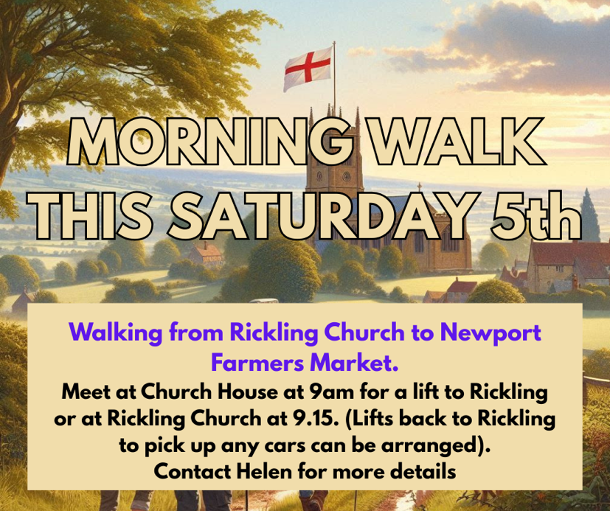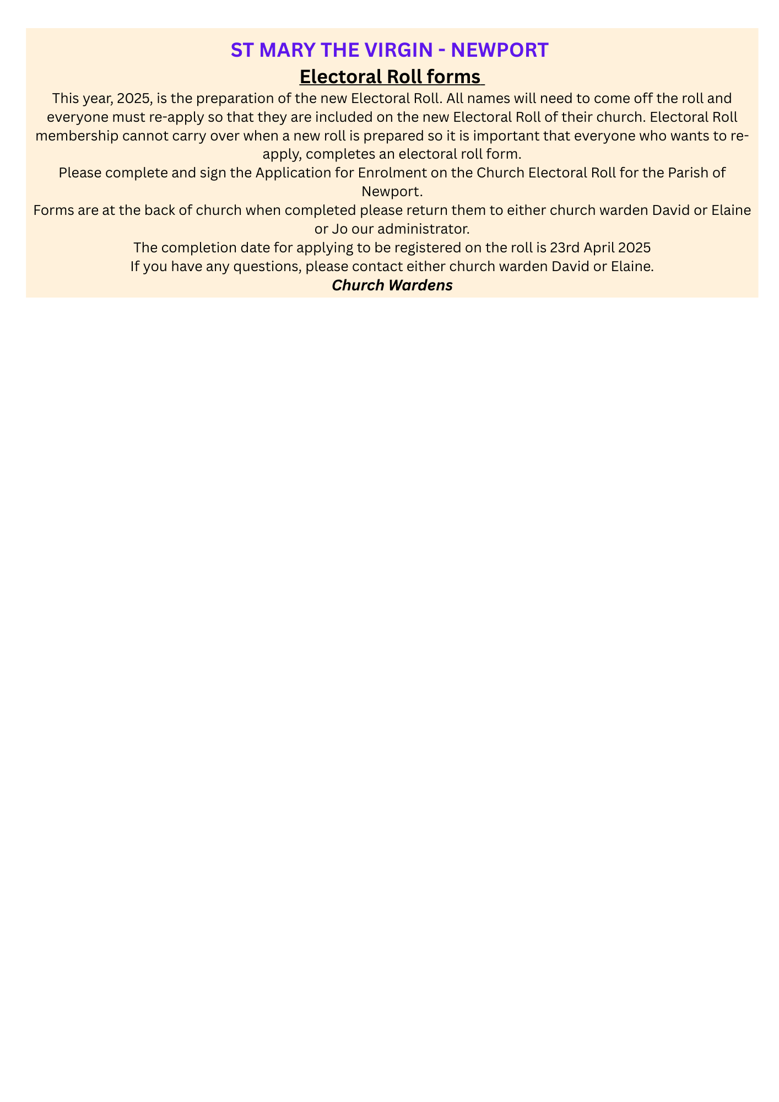

**REVEREND PETER ALLEN**

Priest at Newport, Widdington, Quendon and Rickling.

Lead Chaplain at Stansted Airport

07878 176551 [revpete07@gmail.com](mailto:revpete07@gmail.com)

[revpete07@gmail.com](mailto:revpete07@gmail.com)

**REVEREND GAVIN SUNSHINE**

07379 299845 [revgav24@gmail.com](mailto:revgav24@gmail.com)

**NEWPORT**

**Elaine Edwards**

07540 062140 [account2me2004@yahoo.co.uk](mailto:account2me2004@yahoo.co.uk)

**David Baker**

07510 308068 [david.baker123@talktalk.net](mailto:david.baker123@talktalk.net)

**WIDDINGTON**

**Sonia Whalley**

01799 540066 [soniawhalley@aol.com](mailto:soniawhalley@aol.com)

**QUENDON & RICKLING**

**Christine Osbourn** [christineandos@gmail.com](mailto:christineandos@gmail.com)

Rickling contact [vicar4nqrwchurches@gmail.com](mailto:vicar4nqrwchurches@gmail.com)

**Jo Cundall**

07905 833372 [church.jo@yahoo.com](mailto:church.jo@yahoo.com)

[Vicar4nqrwchurches@gmail.com](mailto:Vicar4nqrwchurches@gmail.com)

**Church office open every**

**Friday 9am -10.30am from Friday 10th January**

|  |  |
| --- | --- |
|  |  |

**Sarah Godfrey**

01799 541157 sarah_jane_godfrey@yahoo.co.uk

**Contact:** [Vicar4nqrwchurches@gmail.com](mailto:Vicar4nqrwchurches@gmail.com)

**We are committed to Safeguarding Children, Young People, Victims of Domestic Abuse and Vulnerable Adults.**

](https://www.youtube.com/@newportessex7920/streams)

**CHURCH WEBSITES & SOCIALS**

[www.stmarynewport.org.uk](http://www.stmarynewport.org.uk)

[www.quendonandrickling.co.uk/churches/](http://www.quendonandrickling.co.uk/churches/)

**Yvonne Hannant**

01799 541063  [churchhousenewport@hotmail.com](mailto:churchhousenewport@hotmail.com)

**[](https://www.facebook.com/stmarysnewport)**

@Newportchurch